**Module 10 – Single Page Application framework – React**

**3.ReactJS-HOL**

**What Are React Components?**

**React Components** are the building blocks of any React application. Each component represents a piece of the user interface.

A component can be:

* A small part of the screen (like a button)
* Or a full page layout (like a dashboard)

Components make it easy to reuse and manage code, especially in large projects.

Example: A Header component can be reused on multiple pages like Home, About, Contact.

**Difference Between JavaScript Functions and React Components**

| **Feature** | **JavaScript Function** | **React Component (Function)** |
| --- | --- | --- |
| Purpose | Performs logic and returns values | Returns JSX (UI) |
| Returns | Any data (number, string, object) | JSX (HTML-like structure) |
| Used in React UI? | No | Yes |
| Accepts props | Not designed for that | Designed to receive and use props |
| Naming Convention | Can be lowercase | Always start with **uppercase** |
| Example | function add(a, b) | function Welcome(props) |

**Types of React Components**

React supports two main types of components:

**1. Class Components**

* Built using the ES6 class keyword
* Must extend from React.Component
* Has access to lifecycle methods
* Uses constructor() and render() methods

**2. Function Components**

* Simple JavaScript functions
* Accept props as arguments
* Do not have lifecycle methods by default (can use Hooks like useEffect)
* Easy to write and maintain
* Preferred in modern React apps

**4. Explain Class Component**

A **Class Component** is a JavaScript class that extends React.Component and must include a render() method.

**Syntax:**

import React, { Component } from 'react';

class Welcome extends Component {

render() {

return <h1>Hello, {this.props.name}</h1>;

}

}

export default Welcome;

**Explain Function Component**

A Function Component is a plain JavaScript function that returns JSX.

**Syntax:**

import React from 'react';

function Welcome(props) {

return <h1>Hello, {props.name}</h1>;

}

export default Welcome;

**Features:**

* Simpler and easier to read than class components
* With React Hooks (useState, useEffect), they can now manage state and lifecycle
* Best choice for most components in modern React development

**Define Component Constructor**

In class components, the constructor() method is called before the component is mounted.

**Purpose:**

* Initialize the state
* Bind class methods
* Access props via super(props)

**Example:**

class Student extends React.Component {

constructor(props) {

super(props);

this.state = { name: "Vedaprakash" };

}

render() {

return <p>Student Name: {this.state.name}</p>;

}

}

**Define render() Function**

The render() function is mandatory in every class component. It tells React what to display on the screen.

**Rules:**

* Should return JSX
* Should be pure (no side effects like HTTP calls)

**Example:**

class Welcome extends React.Component {

render() {

return <h1>Welcome, {this.props.name}</h1>;

}

}

**Create a react app for Student Management Portal named scorecalculatorapp and create a function component named “CalculateScore” which will accept Name, School, Total and goal in order to calculate the average score of a student and display the same.**

**Structure:**

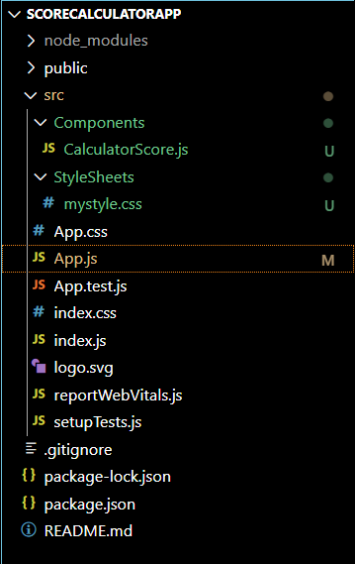

**CalculatorScore.js:**

import React from 'react';

import '../StyleSheets/mystyle.css';

function CalculatorScore(props) {

  const average = props.total / props.goal;

  return (

    <div className="score-box">

      <h2>Student Score Summary</h2>

      <p><strong>Name:</strong> {props.name}</p>

      <p><strong>School:</strong> {props.school}</p>

      <p><strong>Total Marks:</strong> {props.total}</p>

      <p><strong>Goal:</strong> {props.goal}</p>

      <p><strong>Average Score:</strong> {average.toFixed(2)}</p>

    </div>

  );

}

export default CalculatorScore;

**mystyle.css:**

.score-box {

  background-color: #f0f8ff;

  padding: 20px;

  margin: 20px auto;

  width: 400px;

  border: 2px solid #3498db;

  border-radius: 10px;

  font-family: Arial, sans-serif;

  box-shadow: 2px 2px 12px rgba(0, 0, 0, 0.1);

}

.score-box h2 {

  color: #2c3e50;

}

.score-box p {

  font-size: 16px;

  margin: 5px 0;

}

**App.js:**

import React from 'react';

import CalculatorScore from './Components/CalculatorScore';

function App() {

  return (

    <div className="App">

      <CalculatorScore name="Vedaprakash" school="Sona College of Technology" total={480} goal={6} />

    </div>

  );

}

export default App;

**Output:**

